Thank you for purchasing an Agilent solution. To get you started and to assure a successful and timely installation, please refer to this specification or set of requirements.
Correct site preparation is the key first step in ensuring that your instruments and software systems operate reliably over an extended lifetime. This document is an information guide AND checklist prepared for you that outlines the supplies, consumables, space and utility requirements for your equipment for your site.

Summary Chart
Transportation and delivery (the RapidFire system is [H] 170 cm x [D] 81 cm x [W] 155 cm and weighs 475 kg)
Elevator dimensions | [H] | [D] |  | [W]
Elevator maximum weight capacity | kg
Corridor(s) dimensions | [H] |  | [W]
Laboratory entrance | [H] |  | [W]
Laboratory logistics
Space for and around RapidFire | recommended [D] 1.5 m |  | recommended [W] 2.5 m
Vacuum source (check one) | house vacuum |  | stand-alone pump
specifications | flow rate or target pressure |  | manufacturer and model
inlet fitting size | for vacuum tubing of internal diameter 1/4"
Dedicated power outlets (x2) | Hz | V |  | A
Mass spectrometer (MS)
MS manufacturer and model
MS computer operating system | Windows 7 |  | Windows XP
MS data acquisition software | version |  | exact build
Supplies and consumables
Example 96- and 384-well plate | Water (3L) |  | Formic acid (5 mL)
Pipettes and pipette tips | Acetonitrile (2L) |  | Trifluoroacetic acid (5 mL)

Customer Responsibilities

Make sure your site meets the following prior specifications before the installation date. For details, see specific sections within this checklist, including:
- The necessary laboratory or bench space available
- The environmental conditions for the lab as well as laboratory gases and plumbing
- The power requirements related to the product (e.g. number & location of electrical outlets)
- The required operating supplies necessary for the product and its installation.

If Agilent is delivering installation and familiarization services, users of the instrument should be present throughout these services; otherwise, they will miss important operational, maintenance and safety information.

Important Customer Information
- If you have questions or problems in providing anything described as a Customer Responsibilities above, please contact your local Agilent or partner support/service organization for assistance prior to delivery. In addition, Agilent and/or its partners reserve the right to reschedule the installation dependent upon the readiness of your laboratory.
- Should your site not be ready for whatever reasons, please contact Agilent as soon as possible to re-arrange any services that have been purchased.
- Other optional services such as additional training and consultation for user-specific applications may also be provided at the time of installation when ordered with the system, but should be contracted separately.
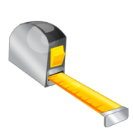 | Dimensions and Weight
Identify the laboratory bench space before your system arrives based on the table below.
Pay special attention to the total height and total weight requirements for all system components you have ordered and avoid bench space with overhanging shelves. Also pay special attention to the total weight of the modules you have ordered to ensure your laboratory bench can support this weight.

Special Notes
- 8 x 8 feet (or 2.5 x 2.5 meters) of space is sufficient for the RapidFire system, mass spectrometer and computer controllers.
- Agilent recommends the laboratory physical arrangement to be such as to minimize the distance between the left wall of the RapidFire platform and the source inlet of the mass spectrometer. This precaution indeed minimizes the length of the fluidic line connecting the two systems.
- Access to the back of the RapidFire instrument (two feet) will be needed on a regular basis to empty waste containers.
Instrument Description | Weight |  | Height |  | Depth |  | Width
Instrument Description | kg | lbs | cm | in | cm | in | cm | in
RapidFire system | 475 | 1045 | 170 | 67 | 81 | 32 | 155 | 61

(left) | 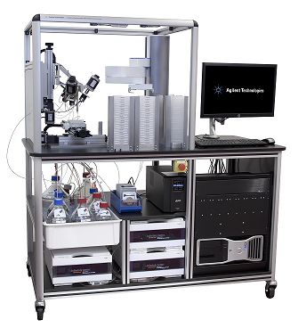 | (right)

Typical RapidFire Setup (view from above)
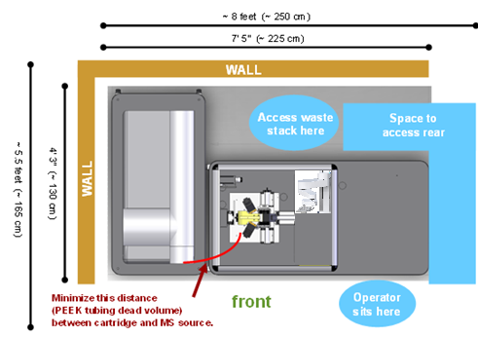

 | Environmental Conditions
Operating your instrument within the recommended temperature ranges insures optimum instrument performance and lifetime.

Special Notes
- Performance can be affected by sources of heat & cold e.g. direct sunlight, heating/cooling from air conditioning outlets, drafts and/or vibrations.
- The site’s ambient temperature conditions must be stable for optimum performance.
- This system requires a source of vacuum with these specifications: 34 L/min of flow and -70 kPa pressure. The barbed-end fitting to the vacuum source will accommodate the ID 1/4" RapidFire vacuum-rated tubing.
Instrument Description |  | Operating temp range °C | Operating humidity range (%)
RapidFire system |  | 4 °C to 35 °C | 0 % to 95 %, non-condensing
 | Power Consumption

Special Notes
- If a mass spectrometer (MS) is supplied in conjunction with your RapidFire instrument, be sure to account for the MS electrical outlets, too.
- Two power outlets are required for operating a RapidFire system
Instrument Description |  | Dedicated Outlet Required (V) | Line Frequency (Hz) | Maximum Power Consumption (W)
RapidFire system US |  | 120 V~ | 50/60 Hz | 1500 W
RapidFire system EU |  | 220 - 240 V~ | 50/60 Hz | 1500 W
RapidFire system JP |  | 100 V~ | 50/60 Hz | 1500 W

Computer Hardware Specifications for
Workstations, Clients, and Servers

Special Notes
- The RapidFire computer (supplied by Agilent) will comply with the following requirements:
Specification Description |  | Minimum
Operating system type(s), versions |  | Windows 7 Pro 64 bits SP1
Processor type and recommended speed |  | Intel Core i7 3770 / 3.4 GHz
O/S .NET & other add-ons |  | .NET 3.5 SP1 .NET 4.0
Language settings/compatibility |  | US English
Memory |  | 8Gb
Mass storage |  | 1 Gb RAID (2 x 1 Gb HDs 7200 rpm SATA-600)
Specific drivers |  | 4 ports RS-232; 4 USB; DVI display port  2 PCI slots; 400 watt power supply  2 Ethernet Controllers (Gigabit Ethernet)  DVD ± RW (±R DL) / DVD-RAM-SATA

Software Specifications for
Workstations, Clients, and Servers

Special Notes
- Full integration between the RapidFire 365 front end and the MS (in order to enable sequence-based batch processing capability in concert with an Agilent or AB Sciex detector) requires one of the following software versions on the MS computer:
Specification Description |  |  | Minimum
MassHunter QQQ |  |  | B.03.01 build 2065  B.04.01 build 4114  B.05.01 build 5027  B.06.00 build 6025
MassHunter QTOF |  |  | B.02.01 build 2116  B.04.00 build 4033  B.05.00 build 5042  B.05.01 build 5125
Analyst QQQ |  | (matching firmware on AB Sciex MS) | 1.5.0 build 3385 or 3655 or 4019  1.5.1 build 4804 or 4810 or 5218  1.5.2 build 5704  1.6.0 build 3773 or 1.6.1 build 5341
 | Networking Specifications

Special Notes
- The RapidFire computer and the mass spectrometer (MS) computer will communicate via a TCP/IP based dedicated network; that is isolated from the MS corporate network.

Required Operating Supplies by Customer

Special Notes
- For information on Agilent consumables, accessories and laboratory operating supplies, please visit http://www.chem.agilent.com/en-US/Products/consumables/Pages/default.aspx
- Please prepare the set of solvents (LCMS grade) listed in the table below to ensure successful installation.
- For your application, you may also need these LCMS-grade, filtered solvents: methanol, acetone, triethylamine (TEA), ammonium acetate, and isopropyl alcohol.
- You may also wish to use 96- and 384-well plates with barcodes on their south end (standard Code 128 ASCII, < 18 characters).
Item Description | Recommended Quantity
Water (H₂O) | 2 L
Acetonitrile (MeCN) | 2 L
Water + 0.09% formic acid (FA) + 0.01% trifluoroacetic acid (TFA) | 2 L
80% MeCN + 20% H₂O + 0.09% FA + 0.01% TFA | 2 L

Important Customer Web Links
- For additional information about our solutions, please visit our web site at http://www.chem.agilent.com/en-US/Pages/HomePage.aspx
- Need to get information on your product?
Literature Library - http://www.agilent.com/chem/library
- Need to know more?
Customer Education – http://www.agilent.com/chem/education
- Need technical support, FAQs? – http://www.agilent.com/chem/techsupp
- Need supplies? – http://www.agilent.com/chem/supplies

Do not include this section in the PDF version.
Print only the checklist for the PDF. Do not include this page. This page is NOT intended for customer viewing. See the guidance instructions at the end of the template for more information.

Document Control Logs

Revision Log
Revision | Date | Reason For Update

Approval Log
Revision | Approver | Title of Approver

